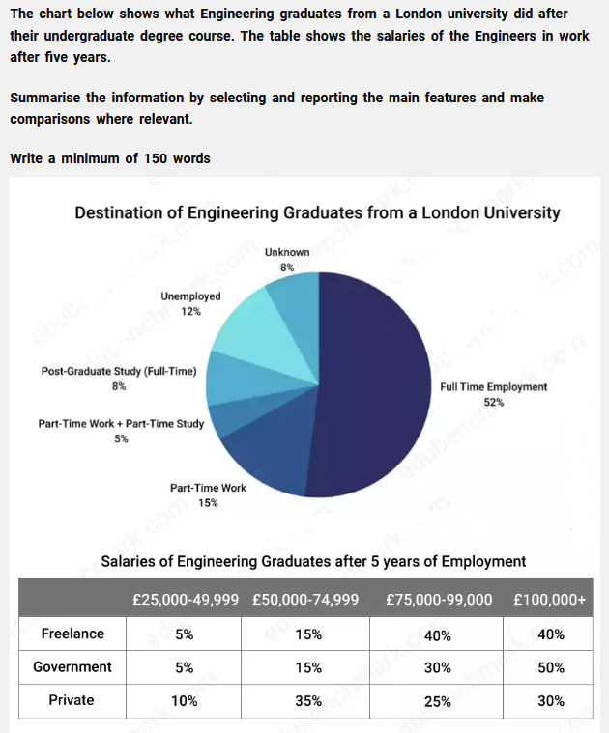

The pie graph illustrates the destination of engineering graduates' employment in percentage from a London University. The table chart below shows salaries distribution after 5 years of employment divided into 3 categories.

Overall, it can be seen that most graduates found a Full Time Job and salaries after 5 years of employment are at a high level.

Firstly, it can be seen that approximately 1 in 10 graduates remain unemployed, also, 8% of students continue to study full time. Nearly double of them prefer to work at a part time job. 5% prefer to combine part time job and study together. The other categories are either unemployed or unknown.

By the second chart, it can be noticed that half of government workers are getting more than 100,000€+ salary, which is more than the percentage of freelance and private workers. There are no graduates that work more than 5 years and getting paid less than 25,000€. Most stable category among these is freelance, in which 80% graduates salary is above 75,000€.

(***170 words***)